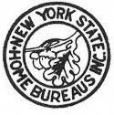
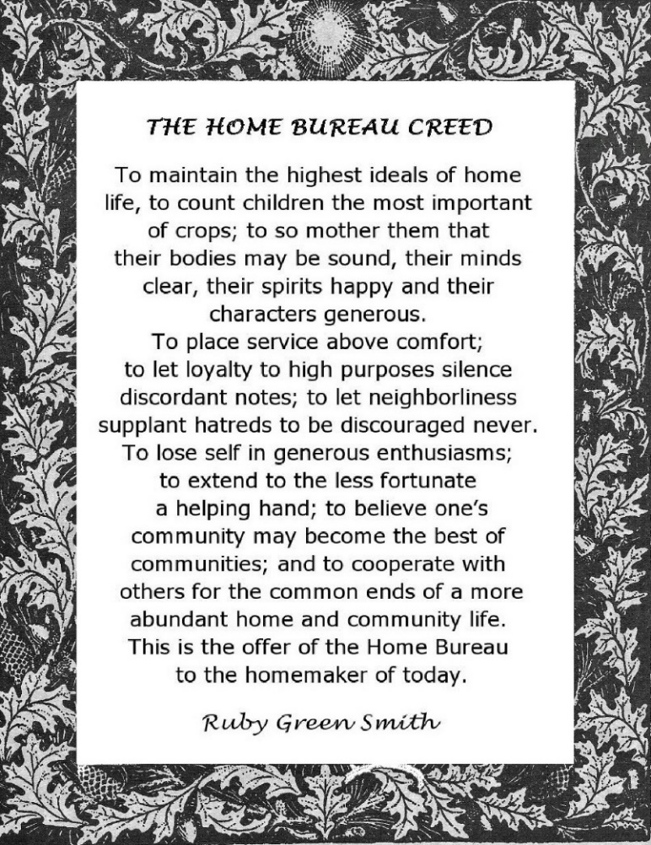
MISSION
STATEMENT

New York State Federation

of

Home Bureaus, Inc.

Oak Leaf is Home Bureau’s emblem and it signifies:

Acorns: a great growth from a small beginning.
Back of the evergreen pine signifies constancy
Of purpose of growth under all conditions.
The many seeded cone carries the idea of fruitfulness.
The direction of growth is upward.
The design culminates at the top in the light of a torch, Founded
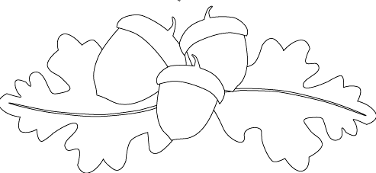
which is typical of the Beacon of Progress and the Gleam Ithaca, New York
of Leadership. May 23, 1919
Revised 2016
- What is the New York State Federation
of Home Bureaus, Inc.?

It is an organization
of New York State homemakers, both urban and rural, non-political, non-sectarian, and non-racial.
It is an independent organization, solely supported by membership dues.

MISSION STATEMENT

Purpose:
The object of this Federation shall be to develop, strengthen and correlate the work of Chapter, County and District Home Bureaus in the State, in their efforts to assist women in promoting all interests pertaining to the higher standards of homes and communities.

AIMS:
Through projects to be better homemakers.
To be more informed and useful citizens.
To promote education – by scholarships.
To help in reducing accidents and having deep concern for health promotion.
To promote peace and understanding.
To sponsor a craft program of interest to all.

PROJECTS:
Community Service
Consumer Education
Crafts
Health and Safety
Legislation
Scholarship

MEMBERSHIP

You are invited to become a member of the New York State Federation of Home Bureaus, Inc.

TO:
Participate in the activities of its program.
Attend the Chapter, County, District and State meetings of the organization.
Receive the Home Bureau Federation “Newsletter”.
Be represented through the Home Bureau State Board affiliations.

FINIS
The New York State Federation of Home Bureau, Inc. is vital and alive, interested in home, community, and state betterment. It is recognized, respected Statewide and is worthy of your interest and support. Won’t you join and share in the satisfying work?

Contact:

New York State Federation
of
Home Bureaus, Inc.

8077 Route 12, Barneveld, NY 13304

www.nysfederationofhomebureaus.com

