FUN GAMES TO PLAY DURING A CHAPTER OR COUNTY MEETING
SCHOLARSHIP FUNDRAISERS
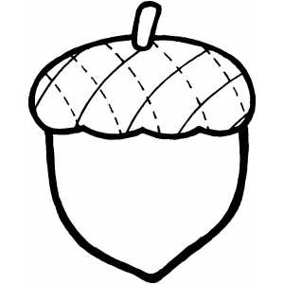
WORD GAME:
Pick a word that is commonly said at your meeting.
Set a price such as a .50
Each time a member says that word they have to pay .50 that will be donated to the scholarship program.
It is fun…try it…….but make sure you pick a word that is commonly said

CROSSED LEG GAME:
Set a price and each time a member crosses their legs they pay that amount to be donated to the scholarship program.

AGE GAME:
Each person adds together the numbers of their birth date and they donate that amount to the scholarship program. Example if the person was born 4-8-1951 she would pay .28

PURSE GAME:
Have each member count the items they have in their purse (not the money)….set a price for them to pay…example: Price is set at 2 cents for each item in the purse…if there are 20 items in the purse she would pay .40 to be donated to the scholarship program.

WRAPPED GIFT ITEM:
Have each person bring two wrapped gifts item to the meeting. The members will bid on the items and the money is donated to the scholarship program. It is fun for some of the wrapped items to be gag gifts but make sure all members know that there is a possibility that the gift they are bidding on could be a gag gift. (My chapter had a chia pet as wrapped gag gift. That chia pet returned each year for several years. It was fun to see who got it each year and how much they paid for it)

DISH TO PASS GAME
Have a dish to pass meeting. Ask each person to bring in their favorite dish and the recipe. Set a price such a 5 cents….then ask each member to count the ingredients in their recipe …they would pay .05 for each ingredient.

